TASK | Using LPG in bottles or cannisters.
LOCATION OF USE | Workshop |  | Assessment  No |  | 0012
PRODUCT NAME | LIQUEFIED PROPANE GAS
DESCRIPTION OF SUBSTANCE | Hydrocarbon mixtures mainly containing butanes, butenes, propane and propene, odorised by mercaptan- LPG
MANUFACTURER | FLOGAS UK LTD
MANUFACTURERS CONTACT | 81 Raynes Way,  Watermead Business Park,  Syston, Leicester. LE7 1PF  01162 624 9185
ASSESSOR | Martin Monaghan CMIOSH |  | Date |  | 04 12 25
TITLE | Health and Safety Consultant |  | Review by |  | 04 12 27
Personnel Performing Task  (Please list below)  Technicians/ Fitters/ Workshop Operatives |  | Time Spent  (Minutes/day)  As and when required, amounting to a few minutes per day | Training Given 
 |  |  | Yes

MSDS Revision Date | Hazard Statement
Sept 2009 Rev:5 | Extremely Flammable (F+).  Readily forms an explosive air-vapour mixture at ambient temperature.  Vapour is heavier than air and may travel to remote sources of ignition (e.g. along drainage systems, into basements etc.).  Liquid leaks generate large volumes of flammable vapour (approximately 250: 1).  Cold burns (frostbite) will result from skin/eye contact with liquid.  Liquid release or vapour pressure jets present a risk of serious damage to the eyes.Abuse involving wilful inhalation of very high concentrations of vapour, even for short periods, can produce unconsciousness or might prove fatal. Inhalation may cause irritation to the nose and throat, headache, nausea, vomiting, dizziness and drowsiness. In poorly ventilated or confined spaces, unconsciousness or asphyxiation may result.

Assessment to be conducted in Association with Hazard Data Sheets, a full current copy of which must be attached to this assessment.

Please denote the hazardous properties of the substances used in the task with a 

NEW INTERNATIONAL GLOBALLY HARMONISED HAZARD SYMBOLS
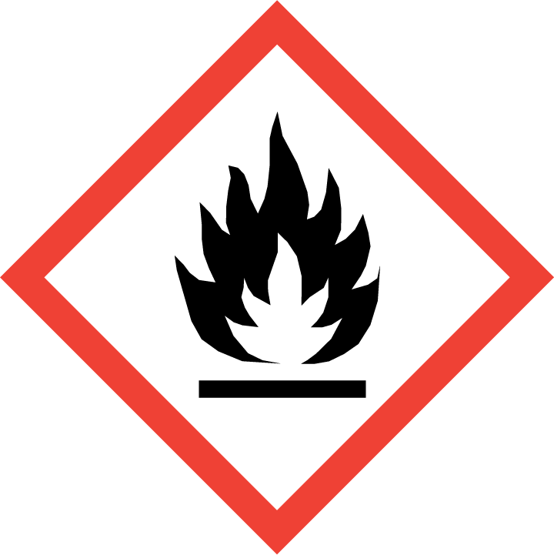 | 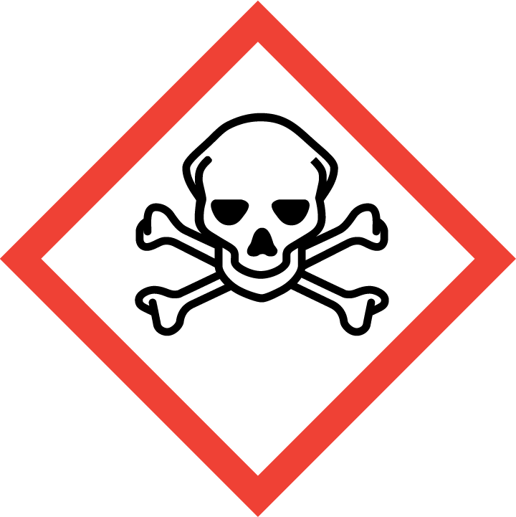 | 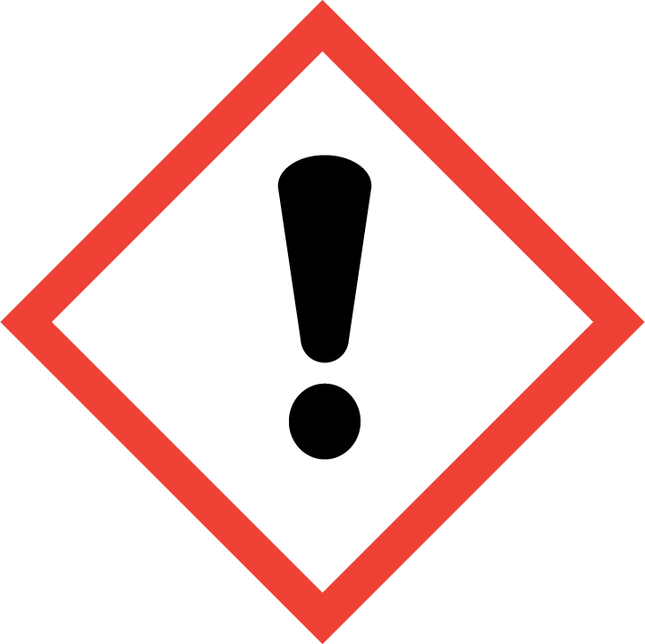 | 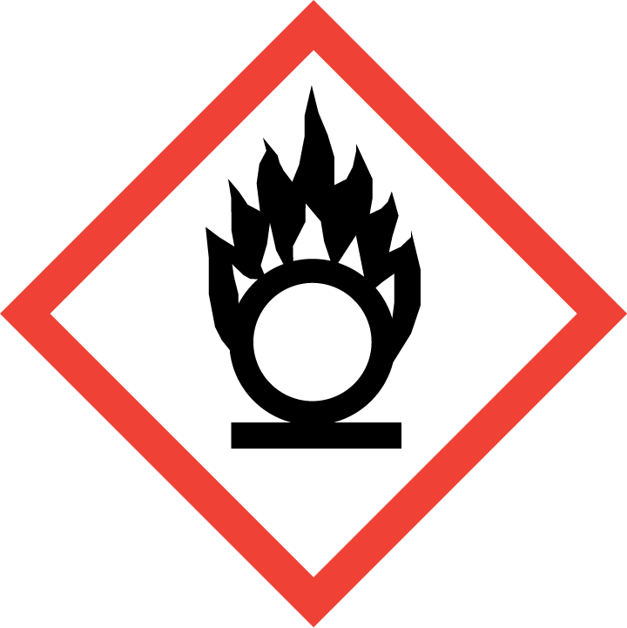 | 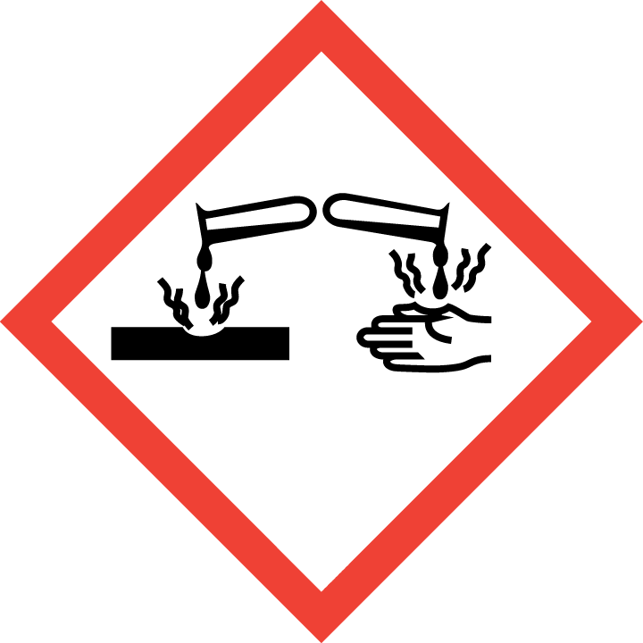 | 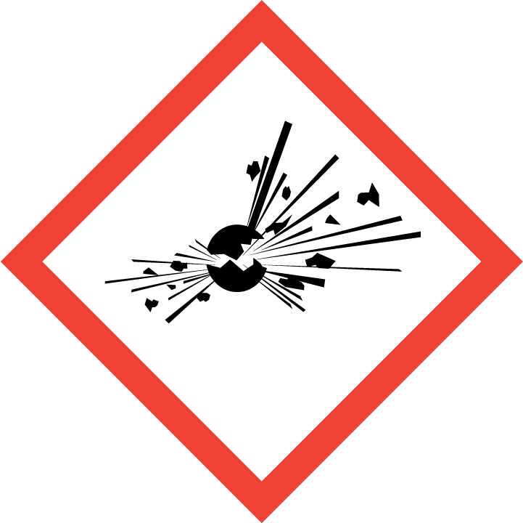 | 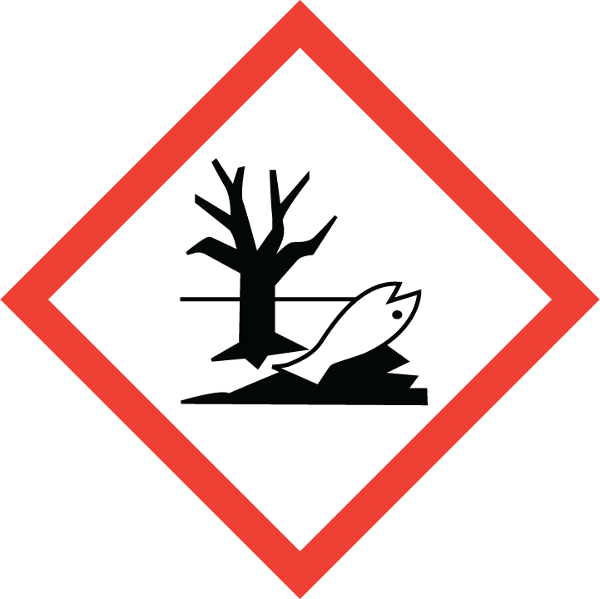 | 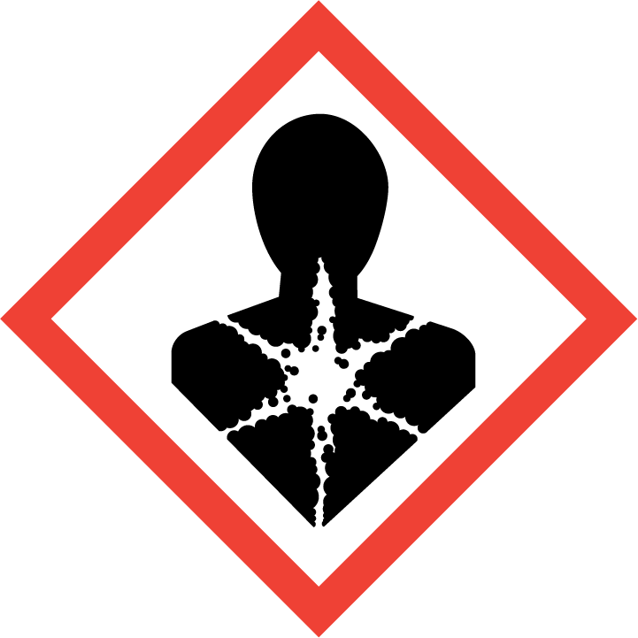
Flammable | Toxic | Harmful | Oxidising | Corrosive | Explosive | Harmful to the environment | Health Hazards i.e. respiratory sensitisation or carcinogenicity
 |  | 

SMOKING, EATING AND DRINKING ARE PROHIBITED IN THE WORK AREAS.
Information, Instruction and Training must be provided to all users. Young Persons, New or Expectant Mothers and other vulnerable groups must not use or be exposed to this product.

WORKPLACE EXPOSURE LIMITS (WEL’s)
The hazardous ingredients in this product which have WEL are:
Hydrocarbons, Carbon dioxide, Oil mist, mineral oil

IMPORTANT!
Refer to Workplace Exposure Levels information provided in the Manufacturers Safety Data and revise control measures if exposure levels likely to be reached.

ROUTE OF EXPOSURE
Skin |  | Eyes |  | Inhalation | 
Ingestion |  | Cuts/abrasions |  | Systemic

PERSONS AT RISK
User of product |  | Co workers |  | Members of the public

ROUTE OF EXPOSURE |   FIRST AID MEASURES
Eyes | Rinse thoroughly with water, keep the eye protected and consult a specialist.
Skin | Rinse thoroughly with water.
Inhalation | The subject should be taken outdoor and kept in a resting position. If suffering from respiratory difficulties or loss of consciousness, call a doctor immediately and administer respiratory assistance.
Ingestion | Immediately rinse mouth and drink plenty of water or milk. Keep person under observation. Do not induce vomiting. If vomiting occurs, keep head low. Transport immediately to hospital and bring along these instructions.
In all cases of doubt, or if symptoms persist seek medical attention. Never give anything by mouth to an unconscious person. If unconscious, place in recovery position and seek medical advice.

PERSONAL PROTECTIVE EQUIPMENT
 |  |  |  | 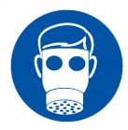 |  | 
YES | YES | YES/NO |  | YES/NO | YES | YES/NO
 |  |  |  |  | 
Wear approved chemical safety goggles where eye exposure is reasonably probable. | Wear appropriate clothing to prevent repeated or prolonged skin contact. |  |  |  | For prolonged or repeated skin contact use suitable protective gloves. Nitrile gloves are recommended.

HANDLING | STORAGE | TRANSPORT | DISPOSAL
Follow the instructions indicated on the containers. Use only in well ventilated areas; do not smoke. Use exclusively with suitable appliances (indication on containers). Always use the containers in the upright position. In workshops, avoid the build-up of electrostatic charges. Never look for a leak with a naked flame. Only soapy water should be used. Never look for a leak with a naked flame. Only soapy water should be used. | Store in a well- ventilated area, well away from all sources of heat and ignition. Do not expose containers to a temperature greater than 50°C. Do not store below floor level (basement or cellar, for example). Store away from low-level points where vapours can accumulate. Do not store in a vehicle (heating by the sun). Avoid contact with strong oxidising agents and keep away from combustible materials. Observe the regulations in force for storing in large quantities. | Flammable gas. | Dispose of waste and residues in accordance with local authority requirements.

REQUIRED CONTROL MEASURES
- Butane and its mixtures are manufactured, stored, transported and distributed under pressure in liquefied form. In normal conditions, they remain in sealed systems up until their final destruction by combustion (use), and are therefore never handled directly. The continual confinement of these gases is of utmost importance. Avoid contact of the liquefied gas with the skin.
- Users to avoid contact with skin and eyes, and inhalation of vapours/ spray or mist arising from the application of this preparation – Use PPE.
- Ensure operatives are made aware of and understand the purpose of this assessment and MSDS, plus any health implications of using the product.
- Ensure COSHH assessments with accompanying MSDS are made available for all employees and users and for inspection and emergency purpose.
- Carry out personal exposure monitoring.
- Wash promptly if skin becomes contaminated. Wash hands at the end of each work shift and before eating, smoking and using the toilet.

FIRE PRECAUTIONS
Suitable extinguishing agents:
.EXTINGUISHING MEDIA
Recommended: powder, CO2,spraying with water in certain cases.
ill-advised : hosing with a concentrated stream of water
Ineffective : foam
.
UNUSUAL FIRE & EXPLOSION HAZARDS
Incomplete combustion creates toxic CO the inhalation of which is particularly hazardous. It is dangerous to put out a flame if the leak cannot be completely stopped.
PROTECTIVE MEASURES IN FIRE
As soon as a fire breaks out, evacuate alI exposed flammable materials and LPG containers. Thoroughly
cool by spraying with water alI containers that cannot be evacuated. Do not hose down with a
concentrated stream of water. If a container that is connected to an appliance catches fire, do not throw
or turn it upside-down, as this can only exacerbate the problem (spilling of liquid gas or container
rupture). Try to close the valve, protecting your hands and forearms with a wet cloth. If possible, take the
container outside without lying it down. Keep people away. Never tip a container on fire.

ACCIDENTAL RELEASE/SPILLAGE PROCEDURES
If leak cannot be stopped by moving the valve, take the container outdoor, avoid any impact and dispose of it in a safe area without turning it upside down.

In the event of a leak, as gas is heavier than air, it has a tendency, in the absence of ventilation, to accumulate at the lowest possible levels. The intense heating of a container can cause it to rupture, allowing the product to escape; the ignition of vapour can give rise to deflagration or explosion.

MONITORING REQUIREMENTS AND HEALTH SURVEILLANCE
Health surveillance is not in place for workers exposed to this product.

